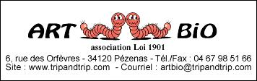

Becoming a member of the Art Bio Association is very easy, you just have to fill in the form below and send it back to us together with your cheque at the following address:

Art Bio Association membership for 2006

Name: ________________________________________
Forename: ______________________________________
Address: ______________________________________
Tel.: _________________________________________
Email: ________________________________________

- Membership: 10 €
- Membership unemployed/students: 8 €
(please, send us a copy of your status)
- Membership for benefactor members: 50 € ou +
I wish to:

 Become a member of the Art Bio Association for 2006 and I add
the sum of € by cheque libelled at the Association Art Bio.

 Become a benefactor member of the Art Bio Association for 2006 and I add
the sum of € by cheque libelled at the Association Art Bio.

Date Signature

You will beneficiate of various advantages:

- Become a member of the « convinced recyclers », recycling artists, worms’ lovers and all the innovators in the recycling field.
- Be informed of local, regional and national exhibitions and shows about these themes.
- Beneficiate of reductions for exhibitions.
New Beneficiate of a reduction when buying a worm-composter Can-O-Worms
From the Vers La Terre company.

